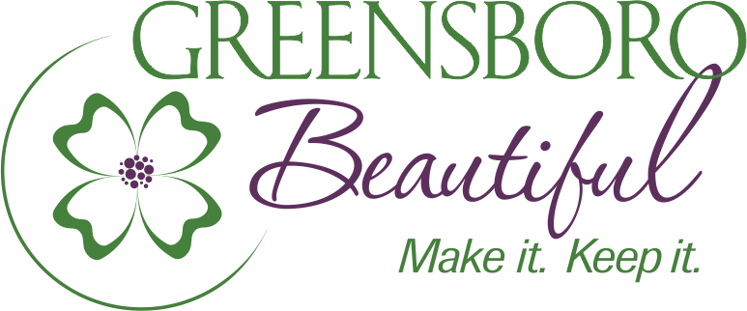
Greensboro Beautiful is pleased to offer a Tribute Bench program to users of our gardens to honor or memorialize a loved one and enhance the meaning of a bench to users of our gardens. A memorial or honor bench is the perfect way to accent one of our public gardens and can be inscribed with a message of love, recognition, hope or inspiration.
Process: Members of the public may request a memorial or honor tribute bench by requesting, completing, and submitting a Bench Application form to Greensboro Beautiful, INC.
Applicants may request a bench in a specific public garden, including the Arboretum, Tanger Family Bicentennial Garden, the Bog Garden, and Gateway Garden. Greensboro Parks and Recreation staff, in conjunction with Greensboro Beautiful, Inc., will evaluate location requests to determine if the requested location is suitable for either adopting an existing tribute bench or installing a new one. If the requested location is not suitable, staff will suggest alternative appropriate locations. Donors will be able to adopt an existing bench or provide for installation of a new bench in a public garden area where there is none, if a need exists. Greensboro Beautiful and Greensboro Parks and Recreation Staff will work with the applicant to select a final location, secure plaque wording, and confirm understanding of the longevity of the bench dedication term. The exact location is subject to approval of Greensboro Parks & Recreation. Greensboro Beautiful, INC. and Greensboro Parks & Recreation reserve the right of full editorial control over content, appearance, and wording on bench plaques. Bench adoptions and installations are usually done twice a year. Generally, an adopted bench will be installed within six months of receipt of contribution; however, due to unforeseen conditions, this period may be extended.
Tribute benches will remain in place for the duration of the adoption period of ten (10) years from the date of installation. If a plaque is placed in recognition on the bench, the plaque will remain for the ten (10) year adoption period as well. At the end of the adoption period, every effort will be made to contact the original donor to re-adopt the tribute bench. The cost of such re-adoption shall be the then current price for adoption of a bench. If the donor does not want to re-adopt the bench, then it will be made available for adoption to the public, and, if applicable, the plaque will be removed and held for pickup for 90 days, upon which time the plaque will be disposed, and the bench will be made available for adoption to the public.
Content: Greensboro Parks & Recreation and Greensboro Beautiful, INC. retains ultimate approval authority over the appropriateness of any inscription. Content must NOT include depictions, words, or phrases that are reasonably deemed to be harmful or otherwise developmentally inappropriate for the purpose of communication with or public display to children. Examples of depictions, words, or phrases that may be rejected under this policy are as follows:
- Sexually suggestive, promote nudity or partial nudity, profanity, lewdness, or characterizations of such including products, activities, or materials;
- Promotion of unlawful discrimination on the basis of race, ethnicity, religion, or any other classification protected by law;
- Connotations of inappropriate violence or intimidation;
- Relating to events, activities, or behaviors that are criminal or otherwise violate law;
- Promotion in any form of illegal drugs, drug use, paraphernalia, alcohol, or glorification of such products, activities, or materials;
- Promotion of issues, candidates, campaigns, or organizations of a political, social, or religious nature;
- Promotion of tobacco products or activities associated with tobacco products; or
- Promotion of activities or products that are reasonably determined to be detrimental to the public health or safety.
Specifications: Tribute bench options (design, color, material, inscription, etc.) shall be strictly limited to those pre-determined by Greensboro Beautiful, INC. and Greensboro Parks and Recreation. Greensboro Parks and Recreation holds ultimate ownership of all benches, and it is prohibited for donors to decorate, personalize, or add adornment to any memorial or honor bench. Special maintenance requests will not be granted except in cases of safety concerns, damage, or vandalism.
Relocation: Greensboro Parks and Recreation reserves the right to relocate, remove, or replace a tribute bench with a comparable product due to safety concerns, capital construction, landscape redesign, or other extenuating circumstances. If the need arises to relocate, remove, or replace a bench during the adoption period, Greensboro Beautiful, INC. and Greensboro Parks & Recreation staff will make every effort to notify the donor prior to re-location, removal, or replacement.
Vandalism or Theft: If a tribute bench is vandalized, stolen, or fails as a result of environmental conditions within the adoption period, Greensboro Parks and Recreation staff will make every effort to repair the bench. If the bench cannot be repaired, Greensboro Parks and Recreation may remove, replace, and/or re-locate the bench. During the adoption period, if repairs cannot be made, a replacement tribute bench will be provided at no cost to the donor. An attempt will be made to replace the bench with the same product model; however, Greensboro Beautiful, INC. in conjunction with Greensboro Parks & Recreation reserves the right to install an alternate design.
If a plaque is placed in recognition on the tribute bench, the plaque will remain for the adoption period. If a plaque is vandalized, stolen, or fails as a result of environmental conditions within the adoption period, a replacement plaque at no cost to the donor will be provided.
Fees and Charges: Cost for adoption is based on the type and location of bench selected as indicated in the Application Form – note the cost to the donor/sponsor will be the same whether it is a newly installed bench or the installation of a new one. Costs for adoption of a bench are subject to change will be reviewed and adjusted at a minimum annually.
Participation in the Tribute Bench Program requires the adoption fee to be paid in full by the donor within ten (10) business days of the application approval. The adoption fee will cover the cost of installation, maintenance, and when applicable, the purchase, inscription, and installation of a commemorative plaque.
Greensboro Beautiful, INC. is a qualified charitable organization, and contributions are eligible for a tax deduction.
Payment:
For payment by credit card, please contact Greensboro Beautiful, INC. at 336 574-3574.
Check payments, payable to Greensboro Beautiful, may be mailed to:
Greensboro Beautiful, Inc.
301 S. Greene Street
Suite 300
Greensboro, NC 27401

